**Commercial property**

**商业地产**

(英文部分选自经济学人20220730期财经版块)

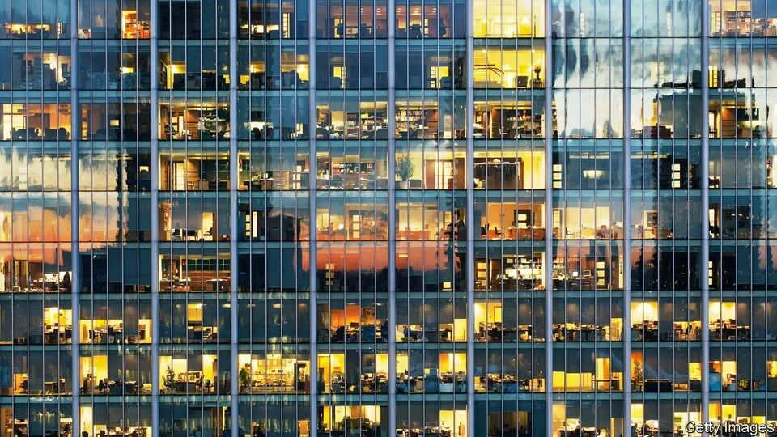

Commercial property

商业地产

Through the floor

跌入谷底

Growth jitters are prompting investors to rethink their portfolios

市场不安情绪蔓延，投资者重新审视资产组合

Property **is usually regarded as** a good hedge against inflation. Landlords’ ability to increase rents can cushion the blow from rising costs. If inflation is driven by strong economic growth, rents **go up**, buildings stay full and landlords **are assured of** rising income.

地产投资常常视为是对抗通胀的一把利器，提高租金是房东用以对冲成本上升的重要手段。在增长拉动型通胀中，租金上涨，一屋难求，房东势必能赚得盆满钵满。

Worries about the economy, however, have **turned** this strategy **on its head**. Strained household budgets and stretched corporate balance-sheets could limit tenants’ ability to pay more rent, jeopardising investors’ returns. Moreover, with the cost of debt rising, owners of office towers, hotels, shopping malls and other types of property risk being stuck with lower returns on assets that may now be overpriced. Many fear a correction is coming.

然而一旦经济状况开始令人担忧，同样的策略，结果却会有着天壤之别。家庭缩减开支，企业资产负债表吃紧，这些都会令租客囊中羞涩，进而影响地产投资者的收益。更重要的是，随着借贷成本的上升，办公楼、旅馆、购物中心及其他地产所有者会因此掉入“低资产回报率”陷阱——其当前资产价值可能已被高估。许多人担心市场调整就在眼前。

注释：

If you turn something such as an argument, fact or theory on its head or stand it on its head, you make it have the opposite effect or meaning.

The darkening mood is **in contrast to** the optimism of 2021, when returns soared, rents rocketed and fundraising, fuelled by low interest rates, raced to record highs. Even as offices remained eerily empty, fund managers rushed to park their capital in new blocks of flats, labs and warehouses, **pushing up** the global value of professionally managed property by nearly $1trn. That stellar performance has since fizzled out. The share prices of listed real-estate investment trusts are tanking and expectations for rental growth and returns are **being scaled back**. In America delinquency rates **crept up** in June for the first time since late 2021.

这种阴郁的情绪与2021年的乐观情绪大相径庭，当时投资回报率高涨，租金猛增，低利率推动融资规模飙升至历史新高。尽管办公室仍然空荡得可怕，但基金经理们纷纷将资金投向新的公寓、实验室和仓库，把全球专业管理房产的价值推高了近1万亿美元。可惜如此亮眼的表现却是烟花易冷。上市房地产投资信托公司的股价正在下跌，对租金增长和投资回报的预期也正在回落。6月，全美贷款逾期率自2021年底以来首次上升。

注释：

1. eerily: 怪诞地；奇异地；可怕地

2.stellar：A stellar person or thing is considered to be very good. 杰出的; 优秀的

3. fizzle: If somethingfizzles, it ends in a weak or disappointing way after starting off strongly. 虎头蛇尾地结束

4.tank：If something such as a stock price or a movie tanks, it performs very badly, for example because it loses a lot of money. 表现得很糟糕

5. delinquency rate：逾期率；过期还款比率

**The strain comes on top of other challenges**. UBS, a bank, expects the shift to remote work to hit leasing demand for offices by as much as 20%. Decarbonisation will require hefty investment in older buildings. Meanwhile, the decline in bricks-and-mortar stores is bad news for shopping-mall owners, and rising air fares threaten the demand for hotels.

**商业地产市场还面临着其他挑战**。瑞士银行预计，远程办公将使办公室的租赁需求下降达20%，老旧建筑去碳化将耗费巨额投资。与此同时，实体店数量的减少对购物中心的业主来说绝非好消息，不断上涨的机票价格也将抑制酒店需求。

注释：

1. Decarbonisation：去碳化，脱碳

2. hefty：Heftymeans large in size, weight, or amount. 庞大的; 沉重的

3. bricks-and-mortar：a building or buildings 建筑物

No wonder investors are tightening their belts. After a record start to 2022, deal activity in America is cooling, says Kevin Fagan of Moody’s Analytics, a research firm. Transactions that are already under way are taking longer to negotiate; some are **being put on hold**. In America and Britain, commercial-property investment between April and June plunged to its lowest level since the pandemic began, to $86bn and £10bn ($12bn), respectively. Dealmaking also fell in Germany.

难怪投资者正在勒紧裤腰带。研究公司穆迪分析的凯文·费根（Kevin Fagan）说，在2022年初的创纪录开局之后，美国的交易活动正在降温。已在进行的交易，谈判战线拉长；有些交易甚至已被搁置。美国和英国4月至6月的商业地产投资跌至疫情开始以来的最低水平，分别降至860亿美元和100亿英镑（折合120亿美元）。德国的交易量也有所下降。

注释：

put on hold延迟；暂缓；搁置

Not all properties will struggle. The highest-quality, most energy-efficient buildings, with modern amenities and on prime sites, typically owned by big institutional investors, are expected to fare relatively well. By contrast, lower-quality assets across Europe lost around a tenth of their value in the second quarter of this year, compared with the previous three months, reckons Green Street, a research firm. That decline follows a poor 2021 for many such buildings: rents for lower-quality offices in London fell by 9% last year, compared with 2020, even as those for prime office space rose by 8%.

并非所有的地产都将面临困境。最优质、最节能的建筑预计将表现良好，这些建筑不仅配备了现代化设施，且地处黄金地段，通常归大型机构投资者所有。相比之下，根据房地产研究公司格林街（Green Street）的估计，与第一季度相比，今年二季度欧洲的低质量地产价值缩水约十分之一。事实上，其中许多建筑在2021年已经经历过一轮大瘦身了：与2020年相比，2021年伦敦低质量写字楼的租金跌了9%。而优质写字楼则涨了8%。

注释：

1. fare：V. If you say that someone or something fares well or badly, you are referring to the degree of success they achieve in a particular situation or activity.

2. Green Street：该公司是一家大型房地产金融分析服务平台，主营业务为提供“房地产和金融市场情报”。

Some cities will do better than others. In America, sunbelt markets such as Atlanta, Dallas and San Diego are expected to be among the top performers this year, providing better returns than places like New York and San Francisco, where workers have been slower to return to the office. Landlords who can guarantee future rent growth or those in markets with constrained supply are also relatively well-positioned. This includes owners of labs, warehouses and other logistics property.

各城市间的表现也参差不齐。在美国，诸如亚特兰大、达拉斯、圣地亚哥等阳光地带的市场，预计今年的表现将名列前茅，为投资者带来更高的回报率，而纽约、旧金山等城市则将受累于员工返回办公室的步伐更加缓慢。租金看涨或房源供不应求当然也将利好房东。这包括实验室、仓库以及其他物流资产的所有者。

The upshot is that, although commercial-property prices might fall, the decline is not forecast to be precipitous. Analysts at Capital Economics, a consultancy, reckon that values in America could face a peak-to-trough fall of 6-8%. That is a bigger decline than the one at the start of the pandemic, but is far from **the plunge of** 34% during the global financial crisis.

结果是，尽管商业地产价格可能下降，但预计降幅不会太大。来自咨询公司凯投宏观（Capital Economics）的诸位分析师表示，美国商业地产价值可能会从波峰到波谷下跌6%-8%，其跌幅虽大于新冠初期的跌幅，但还远不及全球经融危机时34%的跌幅。

Another comfort is that banks have become less exposed to commercial property. In Britain, for instance, it **makes up** almost 7% of lenders’ loan books, compared with 12% before the financial crisis. Offices, malls and warehouses may not provide as much shelter from inflation as investors might like, but they have, at least, become less likely to amplify financial trouble.

令人慰藉的还有银行在商业地产方面风险减小。例如，英国商业地产贷款占贷款人贷款账簿的7%，而金融危机之前这一比例为12%。写字楼、购物中心和仓库也许没法像投资者期待的那样成为通胀庇护所，但至少，也不会轻易成为金融问题进一步恶化的催化剂。